**Romerico David**

**Aimable Mugwaneza**

**Programming Task 1:**

**Programming Task 1 Results:**

**Programming Task 2:**

**Programming Task 2 Results:**

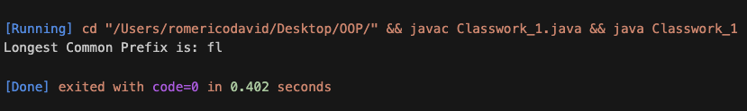

**Answer for question 1:**

In pair programming, two developers collaborate, with one writing code and the other providing immediate feedback. In contrast, traditional programming involves the developer working mainly independently which often lead to delayed feedback and longer processing times.

**Answer for question 2:**Pair programming can be very effective in improving code quality and expanding your skill sets especially in larger and more complex projects. However, it may not work well when the developers have mismatched skills (or even the same skills), as it can slow down productivity.